Architecting a Comprehensive Ukrainian Lexical Database: An Analysis of Open-Source Resources for Natural Language Processing and Pedagogy
The development of a comprehensive, 1774-module Ukrainian language curriculum mapped sequentially from the A1 to C2 proficiency levels of the Common European Framework of Reference for Languages (CEFR) represents a monumental undertaking in both computational linguistics and language pedagogy. Utilizing a Retrieval-Augmented Generation (RAG) pipeline to automate exercises, validate student inputs, and construct contextual narratives requires a lexical foundation that is extraordinarily robust, meticulously structured, and capable of operating entirely offline.
The existing local repository provides an exceptional structural and morphological baseline. The presence of the VESUM morphological dictionary—containing 409,000 lemmas and 6.7 million inflected forms—serves as the critical normalization engine required for a highly synthetic language like Ukrainian. Coupled with the 11-volume SUM-11 explanatory dictionary (127,000 entries), the historical Grinchenko dictionary (67,000 entries), the English-to-Ukrainian Balla translation lexicon, and 125,000 literary text chunks, the foundational architecture possesses immense raw linguistic data. However, authentic pedagogical scaling necessitates transitioning from monolingual definition and forward-translation to a multidimensional relational database.
To power a localized RAG architecture for B1+ distractor generation, syntax modeling, and difficulty-curated text generation, five critical infrastructural gaps remain: bidirectional translational mappings (Ukrainian-to-English), hierarchically structured semantic equivalence (synsets), syntagmatic models (collocations), pedagogically graded frequency lists, and pragmatic metadata (stylistic registers). This comprehensive report provides an exhaustive analysis of open-source, machine-readable, and offline-compatible Ukrainian lexical resources designed to fill these specific architectural voids, utilizing structured formalisms such as JSON, CSV, SQLite, and OntoLex-RDF.

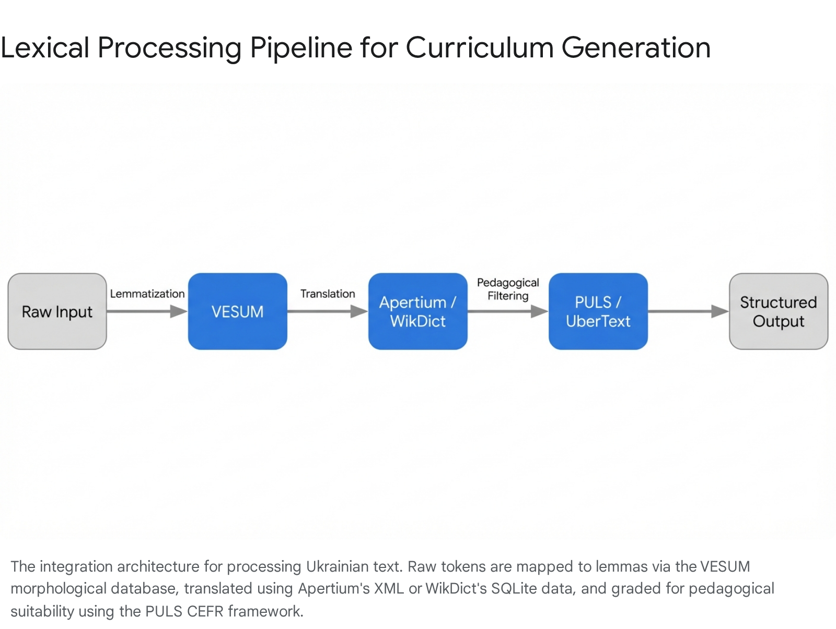

1. The Translational Layer: Reverse-Mapping Ukrainian to English
The current localized architecture contains the Balla dictionary, which provides a robust English-to-Ukrainian mapping.¹ However, a pedagogical RAG system requires a bidirectional translational layer to support "словник" (vocabulary) generation, meaning that a Ukrainian-to-English dictionary is an absolute necessity. Relying on reverse-indexing an English-to-Ukrainian dictionary is computationally problematic; polysemous English words mapped to multiple Ukrainian equivalents do not cleanly invert without creating massive semantic hallucination. Therefore, native, structured Ukrainian-to-English open-source datasets must be integrated.

1.1 Community-Sourced and Machine-Readable Lexicons: WikDict and FreeDict
For broad-coverage vocabulary lookups that prioritize structured database formatting over proprietary API calls, the FreeDict and WikDict initiatives offer the most direct solution for an offline architecture.²
The FreeDict project operates on a rigorous, crowdsourced model that strictly adheres to an open-source ethos.⁴ Crucially for systems architecture, FreeDict stores its primary data in the generic TEI P5 XML format.⁴ The Text Encoding Initiative (TEI) P5 guidelines provide a highly standardized XML schema tailored specifically for linguistic and lexicographic data. By abstracting the dictionary data from its presentation layer, this XML format allows database architects to rapidly parse the dataset and export it into optimized JSON objects or relational SQL tables.⁴ The TEI structure explicitly separates lemmas, parts of speech, and varying translation senses, which is vital for preventing the RAG pipeline from conflating distinct meanings.
WikDict significantly expands upon this ecosystem. It programmatically extracts structured lexicographic data directly from Wiktionary database dumps, but unlike raw, nested MediaWiki dumps, WikDict compiles this information into optimized, query-ready formats.² Most importantly for a local pipeline, WikDict provides pre-compiled SQLite databases.² By utilizing the SQLite format, the curriculum backend can immediately execute complex, high-speed JOIN operations between the UK-EN translation tables and the local VESUM morphology tables.² Furthermore, WikDict offers dictionaries compiled in the StarDict format.² StarDict is universally supported by offline dictionary engines (such as GoldenDict and KOReader) and utilizes a simple index-to-data byte mapping that can be trivially reverse-engineered into Python dictionaries using open-source parsing libraries like PyGlossary.²

1.2 Open-Source Kindle JSON and MOBI Conversions
An often-overlooked vector for acquiring highly structured, offline translation data lies in the e-reader developer community. Projects aimed at building localized Kindle dictionaries frequently compile massive, cleaned datasets. For instance, open-source repositories exist that have processed comprehensive translation lexicons specifically for Kindle integration.¹ One such project processed a massive database containing over 75,000 articles and 155,000 words.¹
Because these projects must eventually compile their data into strict e-reader formats (such as MOBI), their underlying source code frequently contains Python scripts that manipulate raw CSV or JSON files.¹ By examining the source repositories of these open-source Kindle translation tools, curriculum developers can extract the pre-compiled JSON or CSV artifacts. These datasets inherently map various verb conjugations, adjective forms, and plural nouns back to their base English translations, ensuring accurate mappings even when the RAG system encounters heavily inflected text.¹

1.3 Corpus-Derived Lexicography and Automated Generation
Recent advancements in corpus lexicography have demonstrated that high-quality bilingual dictionaries can be autonomously generated from massive web-crawled texts. A landmark 2023 initiative spearheaded by lexicographers (including Vít Baisa) detailed the creation of a massive Ukrainian-English dictionary utilizing a staggering 3-billion-word web corpus.⁸
This project deviated from manual, legacy compilation. Instead, it generated headword candidates by extracting frequency data directly from the corpus, aligning them with translational probabilities, and then subjecting the resulting matrix to post-editing by native Ukrainian speakers via an interface where annotators assigned color-coded flags to verify correctness.⁸ While the overarching goal was 55,000 verified headwords, the initial published phase resulted in 10,000 fully completed and verified entries.⁸ Integrating verified data derived from this contemporary corpus-based methodology is invaluable. It provides highly accurate, modern English equivalents for contemporary conversational and journalistic Ukrainian vocabulary, successfully bridging the diachronic gap between historical dictionaries (like the 1907 Grinchenko lexicon) and modern 21st-century usage.⁸

1.4 The Apertium Framework and Linguistic Linked Open Data (LLOD)
While the RAG pipeline does not require a full Machine Translation (MT) engine, the structured linguistic data utilized by MT systems is highly applicable. The Apertium machine translation platform—an open-source rule-based machine translation (RBMT) system—contains extensive bilingual dictionaries encoded in XML.¹¹ Apertium's architecture maps correspondences between lemmata, explicitly including multi-word lexical units (MWLUs), and specifies morphological changes across language boundaries.¹¹
To make this highly specialized data more accessible to general NLP architectures, the Linguistic Linked Open Data (LLOD) initiative (specifically the LiODi project) has converted these Apertium XML dictionaries into the OntoLex-RDF format.¹³ OntoLex-RDF is a sophisticated ontology for representing lexicons on the Semantic Web. By downloading the Apertium datasets in RDF format, the curriculum developer can ingest the data into a graph database (or parse it into JSON-LD), allowing the RAG pipeline to traverse translation mappings natively as nodes and edges.¹³ This provides an advanced structural layer, allowing the curriculum software to accurately translate highly inflected Ukrainian forms by first reducing them to their lemma via the local VESUM database, and then executing a precise graph query against the Apertium RDF nodes.

2. The Semantic Equivalence Layer: Structuring Synonymy
In sophisticated language pedagogy, particularly at the intermediate (B1) and advanced (C2) levels, the automated generation of multiple-choice questions requires more than simple translation. If the RAG system generates a vocabulary cloze-test, the "distractors" (the incorrect multiple-choice options) must be semantically related to the correct answer to challenge the student, but definitively incorrect in the provided context. Randomly selecting words from a dictionary results in trivial questions; randomly selecting words with similar definitions risks presenting two technically correct answers. This pedagogical hurdle requires a database structured as cognitive "synsets" (synonym sets).

2.1 Theoretical Distinctions: Absolute vs. Quasi-Synonyms
Before integrating any synonym database, the computational architecture must account for the linguistic reality of partial synonymy. Contemporary research into Ukrainian semantic structures, heavily influenced by linguists such as Yu. Apresyan, emphasizes the stark computational distinction between absolute synonyms and quasi-synonyms.¹⁴
Absolute synonyms are a rarity; they are words that have zero semantic divergence and can be substituted in virtually any context.¹⁴ Quasi-synonyms, however, constitute the vast majority of synonymous relationships. These words exhibit minor semantic, referential, communicative, syntactic, collocational, or morphological deviations.¹⁴ For example, a multiple-choice generator that indiscriminately selects a quasi-synonym from a flat list without checking its stylistic or collocational restrictions might generate a sentence that is grammatically valid but stylistically absurd. Therefore, the synonym database must ideally be relational, preserving metadata about the specific nuances of the synonymy.

2.2 Digitization of the Academic "Slovnyk Synonimiv"
The most authoritative foundational text for Ukrainian semantic equivalence is the Slovnyk synonimiv ukrains'koi movy (Dictionary of Synonyms of the Ukrainian Language), published in two volumes by Naukova Dumka in 1999–2000.¹⁴ This monumental academic work contains approximately 9,200 synonymous rows (synsets), which are organized around roughly 4,279 dominant core words.¹⁵ In total, the lexicon encompasses over 17,000 distinct lexical items, representing the deepest semantic mapping of the language.¹⁸
Within this highly structured lexicographic hierarchy, the core of each synonymous row is designated as the dominant lexical unit (the hypernym or primary anchor), which possesses the broadest, most neutral set of semantic features.¹⁵ Subordinate elements branch off from this anchor with highly specific, granular nuances.¹⁵
Efforts to digitize and convert this specific two-volume lexicon into machine-readable formalisms have been central to Ukrainian NLP research over the past decade. Computational linguists have utilized this text as the foundational truth data to build algorithmic synonymizers, methodically mapping the dominant lexical units into relational databases.¹⁴ To utilize this legacy data in a modern RAG pipeline entirely locally, developers have modeled these synonym structures as directed graphs.¹⁹ In this paradigm, nodes represent distinct Ukrainian words, and edges represent the synonymous relations linking them. This graph architecture facilitates the use of advanced node embedding algorithms (such as Node2Vec) to mathematically calculate the semantic distance between potential distractors, allowing the curriculum engine to select distractors that are "close" but not "identical" to the target answer.¹⁹

2.3 The Ukrainian WordNet Initiative: Ukrajinet
While legacy dictionary parsing is valuable, the most highly structured approach to synonymy for modern NLP applications is the WordNet paradigm. A WordNet is a sprawling lexical database of semantic relations where nouns, verbs, adjectives, and adverbs are grouped into sets of cognitive synonyms (synsets) linked by strict conceptual-semantic and lexical relations (such as hypernymy, hyponymy, and meronymy).²⁰ While the Princeton WordNet has served as the gold standard for the English language since its inception ²¹, a fully mature, massive-scale Ukrainian WordNet under an open-source license has historically been an elusive open challenge.²⁰
However, the recent release of the "Ukrajinet" project represents a critical, usable breakthrough for local pipeline developers. Hosted as an open-source repository via GitHub, Ukrajinet 1.0 was developed using an aggressive "expand" methodology.²⁰ Rather than building an ontology from scratch, researchers utilized the Princeton WordNet as a stable pivot structure, subsequently linking it to Wikidata and Ukrainian Wikipedia entries.²⁰ By mapping Ukrainian Wikipedia titles directly to verified synsets in the Princeton WordNet, and identifying hyponyms for each synset, the developers algorithmically constructed a parallel Ukrainian tree diagram.²² Nodes that lacked a direct Ukrainian equivalent were flagged as "gap nodes," and a proprietary Gap Ranking algorithm was proposed to prioritize which gaps required manual translation filling.²²
The inaugural 1.0 release contains 3,360 sets of full synonyms encompassing roughly 8,700 unique words.²³ While heavily focused on the domain of physics and technical terminology in its initial iteration (derived in part from a 2017 dictionary of physical synonymous terms) ²⁰, the underlying computational architecture is what makes it vital for the RAG pipeline. The data is structured in XML and JSON, with each lexeme assigned a unique "LexEntry" ID containing morphosyntactic categories and links to associated concepts via an Interlingual Index (ILI).²⁰ This is the exact data architecture required for high-speed local inference. By importing Ukrajinet's JSON files, the curriculum engine gains immediate access to highly structured, disambiguated semantic nodes, and can easily expand the database using the open-source community's methodology.

3. The Syntagmatic Layer: Deriving Collocational Frameworks
A student may master a word's definition (via the translational layer) and its related concepts (via the semantic layer), but authentic fluency—particularly at the C1/C2 boundary—demands mastery of its syntagmatic properties. Learners must implicitly understand which words naturally co-occur. A native speaker says "heavy rain," not "strong rain," even though the adjectives are semantically similar. A comprehensive collocations dictionary is therefore vital for the RAG pipeline to construct natural-sounding reading passages, validate free-text student input, and ensure that algorithmically generated texts do not sound disjointed or rigidly translated from English templates.

3.1 Lexicographic Collocation Resources
The preeminent academic milestone in this specific sub-domain is Yuri Shevchuk's Ukrainian-English Collocation Dictionary.²⁶ This monumental 1,000-page work provides an unprecedented syntagmatic mapping for the Ukrainian language, effectively combining features of bilingual, explanatory, and combinatorial dictionaries.²⁷ It meticulously documents which adjectives bind to which nouns, and which verbs mandate specific object noun phrases.
However, from an architectural standpoint, Shevchuk's work is predominantly a commercially licensed print and digital text.²⁸ It poses significant legal and technical hurdles for direct, open-source SQL ingestion or bulk JSON conversion.²⁸ To strictly fulfill the engineering requirement for an offline, open-source dataset formatted in structured CSV or JSON, the RAG pipeline must pivot away from manually curated print dictionaries toward the realm of statistical corpus extraction methodologies.

3.2 Statistical Collocation Extraction via Massive Corpora
In computational linguistics, collocations are fundamentally treated as statistical phenomena—they are specific word combinations (N-grams) that occur together within a corpus at a frequency significantly higher than would be expected by random chance.³⁰ Therefore, highly accurate, machine-readable collocational databases can be autonomously generated by calculating specific association measures over massive, rigorously lemmatized textual corpora.³⁰ Common metrics used to identify genuine collocations (separating them from mere frequent co-occurrences like "in the") include Pointwise Mutual Information (PMI), the Log-Likelihood Ratio, and the T-score.³⁰
To generate a bespoke collocations database, the curriculum architect requires an exceptionally large corpus. The optimal open-source resource for this autonomous generation is UberText 2.0, maintained by the lang.org.ua initiative. UberText 2.0 boasts an immense 3.3 billion tokens distributed across five rigorously defined subcorpora: news articles (3.5 GB), the entirety of Ukrainian Wikipedia (806 MB), literary fiction (414 MB), Supreme Court decisions (302 MB), and social media data via Telegram channels (91 MB).³²
Crucially for local database creation, the lang.org.ua project provides the entirety of this corpus not merely as raw text, but in pre-tokenized and deeply lemmatized formats.³² Utilizing the nlp-uk morphological library, the maintainers have processed billions of tokens into their base lemmas.³² To comply with copyright restrictions while maximizing utility for statistical NLP, the texts are distributed as randomly shuffled, lemmatized sentences within highly compressed .bz2 archives.³⁶
This shuffled sentence structure is the perfect raw material for extracting collocations.³⁶ By downloading the lemmatized .bz2 archives locally, the developer can run a standard bigram/trigram extraction script (utilizing libraries like NLTK or SpaCy) over the 3.3 billion tokens. By establishing a minimum frequency threshold (e.g., filtering out N-grams that occur less than 25 times) and calculating the Log-Likelihood Ratio for the remaining pairs, the developer can autonomously output a massive, scientifically rigorous JSON or CSV database of natural Ukrainian collocations.³⁰

3.3 Alternative Reference Corpora
While UberText 2.0 is the most accessible for direct local download, the General Regionally Annotated Corpus of Ukrainian (GRAC) serves as a critical secondary reference. Boasting over 1.9 billion tokens, GRAC is the largest manually compiled and regionally annotated reference corpus of Ukrainian.³⁵ While the entirety of the raw text is restricted due to copyright and only accessible via online corpus managers (like Sketch Engine or KonText), specific subsets, such as the Pluperfect GRAC (PluG) and extensive frequency metadata derived from it, are available.³⁵

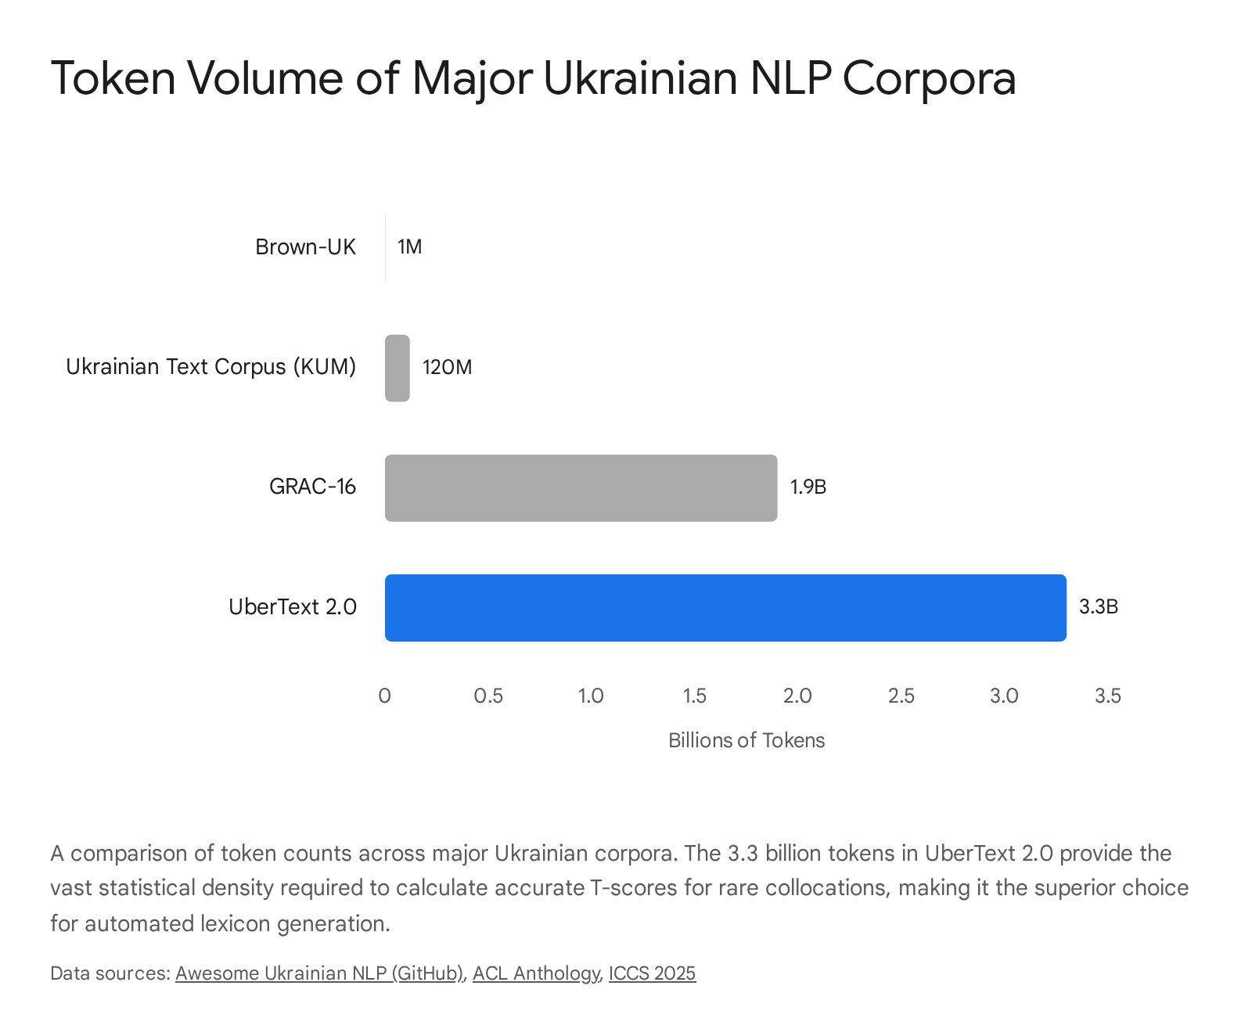

The combination of UberText 2.0's sheer open-source volume and the statistical capability to calculate associative measures dynamically guarantees a syntagmatic database that rivals proprietary print dictionaries, all while remaining natively integrated into the local SQLite framework.³¹

4. The Grading Layer: Frequency Distribution and CEFR Profiling
A curriculum containing 1774 distinct modules spanning absolute beginner (A1) to near-native mastery (C2) must sequence vocabulary introduction flawlessly. The RAG pipeline relies on specific pedagogical constraints; generating a reading passage that inadvertently includes a highly esoteric C1-level word in an A2 module entirely disrupts the learning curve. Therefore, a frequency-ranked word list explicitly and scientifically mapped to the CEFR scale is the cornerstone of the curriculum's generation logic.

4.1 The Curse of Raw Corpus Frequency
A common, highly detrimental pitfall in algorithmic curriculum design is relying solely on raw corpus frequency as a proxy for pedagogical difficulty. The lang.org.ua project generously provides a pre-calculated Lemma Frequency Dictionary based directly on the 3.3 billion tokens of UberText 2.0.³² This is available as a highly compressed CSV file (ubertext_freq.csv.xz), detailing the specific Lemma, its Universal Dependencies Part-of-Speech (POS) tag, its total absolute frequency across the entire corpus, and the specific number of documents in which it appears.³²
While mathematically accurate, raw frequency is inherently distorted by corpus genre.³⁸ Because journalistic news comprises a massive 3.5 GB of the total UberText 2.0 dataset ³², words related to politics, economics, and warfare will exhibit artificially high frequencies. A raw frequency list mapped blindly to CEFR levels might mathematically rank the word "parliament" or "sanctions" higher than "refrigerator" or "uncle," even though the latter are fundamental A1 survival vocabulary and the former are B2/C1 concepts.

4.2 CEFR-Aligned Lexical Profiles: The PULS Framework
To correct this severe genre distortion, the RAG pipeline must intersect raw frequency metadata with pedagogically verified datasets. The most advanced, rigorously reviewed open-source resource for this specific intersection is the PULS Vocabulary Profile.³⁹ Designed explicitly to establish an empirically grounded vocabulary list for Ukrainian as a Foreign Language (UFL), the PULS dataset bridges the crucial gap between raw corpus data and structured curriculum design.³⁹
The PULS researchers bypassed general-purpose web scrapes and instead compiled a highly specific 1-million-word corpus derived exclusively from 21 UFL textbooks.³⁹ They processed this pedagogical text using the nlp-uk toolkit and the VESUM dictionary for precision lemmatization and tagging.³⁹ This meticulous process generated a foundational list of over 37,000 UFL lemmas. The researchers then mapped these lemmas against general-purpose corpora (like GRAC and Brown-UK) to extract baseline frequency data.³⁹
Crucially, they then assigned specific CEFR levels (A1 through C2) to these words based on the scientific principle of "significant onset of use"—identifying the exact proficiency level where a word natively and consistently begins to appear across diverse pedagogical materials.³⁹ The first 5,891 expert-reviewed words have been published via the PULS platform, which is fully searchable and filtered by CEFR level, thematic topic, and part of speech.³⁹
By systematically extracting this highly structured data, the curriculum engine gains a gold-standard baseline. For the remaining vocabulary lying outside the 5,891 curated PULS words, the system can utilize statistical regression: plotting the known CEFR levels of the PULS baseline words against their raw frequency rankings in the UberText 2.0 CSV list to mathematically predict and assign CEFR levels to the remaining 400,000 lemmas residing in the local VESUM database.

4.3 Multilingual Cross-Validation: The Kelly Project
An additional resource for cross-referencing and validating these algorithmically assigned CEFR boundaries is the Kelly Project.⁴¹ This initiative generated robust, corpus-based vocabulary lists tailored specifically for language learners across nine diverse languages.⁴¹ While the primary open-source output focused heavily on languages like Russian, Arabic, and Chinese, the underlying mathematical methodology is highly transferable.⁴¹ The Kelly researchers extracted frequency lists from massive web snapshots, but crucially, they normalized the data into instances per million (ipm) before mapping them to A1-C2 bands.⁴¹ Utilizing ipm normalization formulas alongside the UberText frequency lists allows the curriculum developer to apply the Kelly mathematical model to the Ukrainian data, providing an additional layer of validation for the A1-C2 progression algorithm.
Lexical Dimension | Recommended Open-Source Resource | Data Format & Source | Pedagogical Application in RAG Pipeline
Translation (UK→EN) | Apertium Lexicon / WikDict / FreeDict | RDF, XML, SQLite, StarDict | Precise lemma-to-lemma translational mapping for bilingual exercise generation and glossary lookups.
Semantic (Synonyms) | Ukrajinet 1.0 / Slovnyk Synonimiv | JSON, XML, Graph Data | Generating highly related but contextually incorrect multiple-choice distractors for B1+ assessments.
Syntagmatic (Collocations) | UberText 2.0 (via statistical extraction) | Lemmatized sentences / CSV | Validating natural phrasing and generating cloze-test sentences with high T-score noun-adjective pairings.
Grading (Frequency/CEFR) | PULS Profile / UberText Freq List | CSV, JSON | Sequencing vocabulary introduction; preventing esoteric C1 words from appearing in beginner A1 modules.
Pragmatic (Register) | Ukrainian Formality Dataset / SUM-11 | Parquet, Text classification arrays | Tagging vocabulary as formal/informal to teach pragmatic appropriateness at advanced C1/C2 levels.

5. The Pragmatic Layer: Stylistic Register Labels
The final component necessary for true C1/C2 mastery is deep pragmatic awareness. Advanced learners must learn to seamlessly distinguish between formal, informal, bookish, official, and colloquial registers. A sentence generated by the RAG pipeline might be grammatically flawless and semantically accurate, but pragmatically disastrous if a highly colloquial idiom is injected into a formal business context. The pipeline requires a dataset of stylistic register labels to guide its own text generation and properly evaluate user inputs.

5.1 Machine Learning Datasets for Formality Classification
Recent advancements in zero-shot classification and cross-lingual transfer in Ukrainian NLP have yielded specific, high-quality datasets designed exclusively for text classification and formality detection. The Ukrainian Formality Dataset is a highly valuable, first-of-its-kind open-source resource available via the Hugging Face hub.⁴² It was created by utilizing state-of-the-art cross-lingual methodologies to translate the massive English GYAFC (Grammarly's Corpus of Yahoo Answers Formality Corpus) dataset into Ukrainian using advanced neural machine translation models, followed by rigorous algorithmic balancing procedures.⁴²
This dataset provides explicit binary labels (0 for informal/conversational, 1 for formal/official) mapped across a vast array of textual instances.⁴² By passing the core curriculum's vocabulary list (or common N-grams) through a lightweight classifier fine-tuned on this Ukrainian Formality Dataset, the pipeline can autonomously append formality confidence scores to tens of thousands of words, effectively creating a structured JSON dictionary of stylistic registers.⁴²

5.2 Feature Extraction via StyloMetrix
For more granular stylistic analysis that moves beyond a simple binary formal/informal label, the StyloMetrix package for the Ukrainian language offers a powerful open-source Python solution.⁴⁴ Originally developed for Polish and English, StyloMetrix incorporates 104 distinct computational metrics that evaluate deep grammatical, stylistic, and syntactic patterns within texts.⁴⁴ While StyloMetrix is technically a corpus analysis tool rather than a static dictionary lookup table, its analytical pipeline can be deployed offline to automatically profile the stylistic register of any text chunk.⁴⁴
For curriculum development, the RAG pipeline can feed the 125,000 literary and historical text chunks already residing in local possession through the local StyloMetrix engine. The engine will evaluate the lexical and syntactic features, generating metadata that categorizes the text chunks by specific genre and register (e.g., official, conversational, archaic, bookish).⁴⁴ The specific words and lemmas predominantly localized within specific stylistic chunks can then be automatically tagged in the central SQLite database with their corresponding register labels.

5.3 Extracting Metadata from Explanatory Dictionaries
Finally, legacy explanatory dictionaries inherently contain extensive stylistic markup, which is often neglected during simple keyword parsing. The 11-volume Slovnyk ukrainskoi movy (SUM-11), which is already possessed locally, is replete with standardized stylistic abbreviations located immediately after the headword (e.g., розмовне [conversational], книжне [bookish], офіційне [official], застаріле [obsolete]).⁴⁵
While parsing raw text-based dictionaries is notoriously error-prone, open-source initiatives that have previously digitized Ukrainian lexicons often preserve this vital markup within structured fields.⁴⁵ By writing and executing strict Regular Expression (RegEx) scripts over the digitized XML or JSON representations of SUM-11, developers can programmatically extract these specific stylistic tags.⁴⁵ Once extracted, these tags can be mapped directly to the corresponding lemmas in the VESUM database, instantly populating the stylistic pragmatic layer for over a hundred thousand words with zero machine-learning inference costs.

6. Synthesis: Database Architecture for RAG Integration
The ultimate culmination of these disparate linguistic resources is their synthesis into a unified, high-speed, offline relational database (such as SQLite) or an embedded vector store. The architectural integration process relies heavily on the VESUM morphological dictionary acting as the central, immutable anchor point.
Because Ukrainian is a highly inflected, synthetic language, raw surface tokens drawn from reading texts or inputted by a student are largely useless for direct database lookups.³⁵ Every single operation in the RAG pipeline must begin by passing the raw string through VESUM to retrieve its definitive lemma and Universal Dependencies Part-of-Speech (POS) tag.³⁹
Once successfully lemmatized, the central architecture utilizes this lemma as the primary key to execute high-speed concurrent queries across the peripheral databases:
- The Translation Query: The lemma queries the SQLite WikDict or Apertium RDF tables to fetch the precise English equivalent, ensuring glossaries map exactly to the text.²
- The Semantic Query: The lemma queries the Ukrajinet JSON structure to return the associated synset array, selecting viable distractors for multiple-choice generation.²²
- The Grading Query: The lemma queries the PULS and UberText frequency tables to verify if its assigned CEFR level matches the mathematical difficulty constraints of the current curriculum module.³²
- The Register Query: The lemma is cross-referenced against the stylistic tags extracted from SUM-11 or the Formality Dataset, ensuring the chosen word fits the social context of the generated dialogue.⁴²
Building the world's first fully comprehensive A1–C2 Ukrainian language curriculum through an automated, offline RAG pipeline is an engineering task that cannot rely on a single lexical source. By strategically aggregating these specialized open-source datasets—Apertium and WikDict for translation, Ukrajinet for semantic equivalence, UberText 2.0 for rigorous statistical collocation derivation, the PULS framework for pedagogical CEFR alignment, and the Formality Dataset for stylistic register—a deeply structured, multidimensional database can be fully realized. This multi-layered architectural approach ensures that the educational engine understands not merely what a Ukrainian word translates to, but exactly how, when, at what proficiency level, and with whom it should be naturally utilized.

Works cited
- pavlo-liapin/kindle-eng-ukr-dictionary: English-Ukrainian Dictionary for Kindle in MOBI format - GitHub, accessed March 24, 2026, https://github.com/pavlo-liapin/kindle-eng-ukr-dictionary
- Download - Wikdict, accessed March 24, 2026, https://www.wikdict.com/page/download
- Index of /dictionaries/stardict/ - WikDict, accessed March 24, 2026, https://download.wikdict.com/dictionaries/stardict/
- Home — FreeDict, accessed March 24, 2026, https://freedict.org/
- Downloads — FreeDict, accessed March 24, 2026, https://freedict.org/downloads/
- Download freedict-eng-deu-0.3.7.slob (Free Dictionaries) - SourceForge, accessed March 24, 2026, https://sourceforge.net/projects/freedict/files/eng-deu/0.3.7/freedict-eng-deu-0.3.7.slob/download
- stardict dictionary files free download - SourceForge, accessed March 24, 2026, https://sourceforge.net/directory/?q=stardict%20dictionary%20files
- Rapid Ukrainian-English Dictionary Creation Using Post-Edited Corpus Data, accessed March 24, 2026, https://elex.link/elex2023/wp-content/uploads/114.pdf
- eLex 2023 Conference Proceedings | PDF | Part Of Speech | Noun - Scribd, accessed March 24, 2026, https://www.scribd.com/document/738794030/elex2023-proceedings
- Electroniclexicographyinthe21stc, accessed March 24, 2026, https://elex.link/elex2023/wp-content/uploads/elex2023_book_of_abstracts.pdf
- Apertium: a free/open-source platform for rule-based machine translation - RUA, accessed March 24, 2026, https://rua.ua.es/bitstream/10045/143999/1/Forcada_etal_2011_MachineTranslation_accepted.pdf
- apertium-cy – a collaboratively-developed free RBMT system for Welsh to English Francis Tyers, Kevin Donnelly, accessed March 24, 2026, https://kevindonnelly.org.uk/resources/words/Tyers2009_apertium-cy.pdf
- Datasets, accessed March 24, 2026, https://acoli-repo.github.io/liodi/data/
- Synonymizer of the Ukrainian Language: Stage of Creation, Features of a Database Update and Software Implementation - CEUR-WS.org, accessed March 24, 2026, https://ceur-ws.org/Vol-2870/paper33.pdf
- MONDILEX Conceptual Modelling of Networking of Centres for High-Quality Research in Slavic Lexicography and Their Digital Resources, accessed March 24, 2026, http://mdl.cc.bas.bg/ludmila/LD/MONDILEX-book.pdf
- Thesaurus Research Articles - Page 3 | R Discovery, accessed March 24, 2026, https://discovery.researcher.life/topic/thesaurus/17613368?page=3
- КУЛЬТУРА ТА ІНФОРМАЦІЙНЕ СУСПІЛЬСТВО ХХІ СТОЛІТТЯ, accessed March 24, 2026, http://repositsc.nuczu.edu.ua/bitstream/123456789/18720/1/Conf-%D0%B0%D0%BF%D1%80%D0%B5%D0%BB%D1%8C-2023-Tes-%D1%871.pdf
- Перша іноземна | PDF | Linguistics | Word - Scribd, accessed March 24, 2026, https://www.scribd.com/document/655892957/%D0%9F%D0%B5%D1%80%D1%88%D0%B0-%D1%96%D0%BD%D0%BE%D0%B7%D0%B5%D0%BC%D0%BD%D0%B0
- ENHANCING DOCUMENT REPRESENTATIONS WITH SYNONYMS GRAPH NODE EMBEDDINGS - Journal of Theoretical and Applied Information Technology (JATIT), accessed March 24, 2026, http://www.jatit.org/volumes/Vol100No1/7Vol100No1.pdf
- Towards Ukrainian WordNet: Incorporation of an Existing Thesaurus in the Domain of Physics - ACL Anthology, accessed March 24, 2026, https://aclanthology.org/2023.konvens-main.12.pdf
- WordNet, accessed March 24, 2026, https://wordnet.princeton.edu/
- Proceedings of the Third Ukrainian Natural Language Processing Workshop (UNLP) @LREC-COLING-2024 - ACL Anthology, accessed March 24, 2026, https://aclanthology.org/2024.unlp-1.pdf
- Building Antonymy Relations in KeNet based on PWN - ResearchGate, accessed March 24, 2026, https://www.researchgate.net/figure/Building-Antonymy-Relations-in-KeNet-based-on-PWN_tbl1_348264475
- Towards Ukrainian WordNet: Incorporation of an Existing Thesaurus in the Domain of Physics - ResearchGate, accessed March 24, 2026, https://www.researchgate.net/publication/378709372_Towards_Ukrainian_WordNet_Incorporation_of_an_Existing_Thesaurus_in_the_Domain_of_Physics
- Lexicographic Post-processing and Refinement Issues in Wordnets - Lexikos, accessed March 24, 2026, https://lexikos.journals.ac.za/pub/article/view/2102/1148
- Recommendations for online Ukrainian dictionaries? - Reddit, accessed March 24, 2026, https://www.reddit.com/r/Ukrainian/comments/x95kzc/recommendations_for_online_ukrainian_dictionaries/
- Ukrainian-English Collocation Dictionary - Ukrainian National Museum of Chicago, accessed March 24, 2026, http://ukrainiannationalmuseum.org/ukrainian-english-collocation-dictionary/
- A Dataset for Hierarchical Classification of Lexical Functions for Collocations in Spanish Yevhen Kostiuk1, Grigori S - arXiv, accessed March 24, 2026, https://arxiv.org/pdf/2311.04189
- Title:The End of History is the Beginning of Myth: The Post-Industrial Town of Wałbrzych in the Works of Polish Playwrights Aut - AATSEEL, accessed March 24, 2026, https://www.aatseel.org/100111/pdf/abstracts/1051/Post.pdf
- D8.1 REPORT OF THE TOOLS FOR THE BASIC NATURAL LANGUAGE PROCESSING (NLP) TASKS IN THE CLS CONTEXT, accessed March 24, 2026, https://clsinfra.io/wp-content/uploads/2023/05/2023-03-14-2022_d81.pdf
- PoS distribution (in %). | Download Table - ResearchGate, accessed March 24, 2026, https://www.researchgate.net/figure/PoS-distribution-in_tbl2_313904118
- UberText 2.0 - lang-uk, accessed March 24, 2026, https://lang.org.ua/en/ubertext/
- Introducing UberText 2.0: A Corpus of Modern Ukrainian at Scale - lang-uk, accessed March 24, 2026, https://lang.org.ua/static/downloads/preprints/ubertext_paper.pdf
- PAWUK: extensive annotated web corpus of Ukrainian - The International Conference on Computational Science, accessed March 24, 2026, https://www.iccs-meeting.org/archive/iccs2025/papers/159040089.pdf
- Introducing UberText 2.0: A Corpus of Modern Ukrainian at Scale - ACL Anthology, accessed March 24, 2026, https://aclanthology.org/2023.unlp-1.1.pdf
- Corpora: lang-uk, accessed March 24, 2026, https://lang.org.ua/en/corpora/
- UkrNLP-Corpora, accessed March 24, 2026, https://k-centre.uacorpus.org/corpora.html
- Where can I find the list of Ukrainian words ordered by frequency of use? - Reddit, accessed March 24, 2026, https://www.reddit.com/r/Ukrainian/comments/10ct0gj/where_can_i_find_the_list_of_ukrainian_words/
- Corpus-Based Vocabulary Profiling for Ukrainian: From Lexical Analysis to the PULS Digital Learning Platform - eLex Conferences, accessed March 24, 2026, https://elex.link/elex2025/wp-content/uploads/eLex2025-29-Synchak_etal.pdf
- GitHub - osyvokon/awesome-ukrainian-nlp: Curated list of Ukrainian natural language processing (NLP) resources (corpora, pretrained models, libriaries, etc.), accessed March 24, 2026, https://github.com/osyvokon/awesome-ukrainian-nlp
- Frequency lists for language learners - Serge Sharoff, accessed March 24, 2026, https://ssharoff.github.io/kelly/
- ukr-detect/ukr-formality-dataset-translated-gyafc · Datasets at Hugging Face, accessed March 24, 2026, https://huggingface.co/datasets/ukr-detect/ukr-formality-dataset-translated-gyafc
- fido-ai/ua-datasets: A collection of datasets for Ukrainian language - GitHub, accessed March 24, 2026, https://github.com/fido-ai/ua-datasets
- The Grammar and Syntax Based Corpus Analysis Tool For The Ukrainian Language - Annals of Computer Science and Information Systems, accessed March 24, 2026, https://annals-csis.org/Volume_37/drp/pdf/7698.pdf
- Electronic lexicography in the 21st century (eLex 2019), accessed March 24, 2026, https://elex.link/elex2019/wp-content/uploads/2019/10/eLex_2019-Book_of_abstracts.pdf
- A Search Engine for the Large Electronic Dictionary of the Ukrainian Language (VESUM), accessed March 24, 2026, https://elex.link/ojs/index.php/elex/article/download/33/19/41

